1. **Install MS SQL Server**.

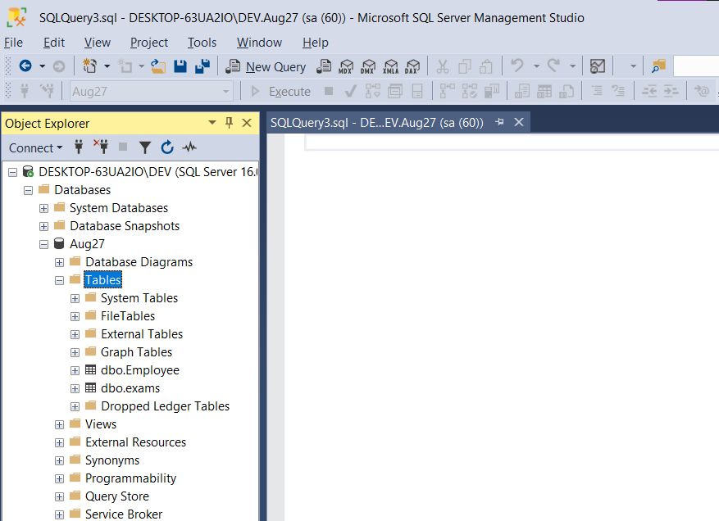

1. **Give the difference between Char and Varchar data type**.

Answer: Char data type allows fixed number of characters mentioned when declaring column name for a table. Memory is allocated for the number of characters declared. Varchar data type allocates storage as necessary for storing the value. Char is more performant compared to varchar because of fixed size and easy access.

If char(10) is declared and string ‘Hello’ is stored in it, memory allocated will be only 10 bytes. If varchar(10) is declared to store the same string, only 5 bytes of memory is used.

1. **Explain the types of SQL Commands**.

Answer: Commands in each type of SQL commands are mentioned against each type.

* DDL – Data Definition Language.
  + Create, Drop, Alter, Truncate, Rename, Comment
* DQL – Data Query Language.
  + Select
* DML – Data Manipulation Language.
  + Insert, Update, Delete, Merge, Call, Explain Plan, Lock
* DCL – Data Control Language.
  + Grant, Revoke
* TCL – Transaction Control Language.
  + Commit, Rollback, Savepoint, Set Transaction, Set Constraint

1. **Explain NVarchar and Nchar**.

Answer:

* A CHAR stores fixed-length, non-unicode characters. A NCHAR stores fixed-length unicode characters. If the data stored in a column is Unicode and can vary in length, then we go for NVARCHAR.
* Nchar and Nvarchar are less performant compared to their counterparts char and varchar respectively.
* Char follows code-set collation order, nchar can follow a localized order, if DB_LOCALE (or SET COLLATION) specifies a locale that defines a localized order for collation.
* Nchar has properties of char - char stores ASCII characters - only english characters, Nchar stores unicode characters - non english characters - other language characters.
* nchar - adds trailing spaces to the data. nvarchar - does not add trailing spaces to the data.
* Nchar / Nvarchar stores double space compared to char/varchar.